Whatever Happened to Stem Cells?
In 1998, the stunning promise of embryonic stem cells was discovered, and it was thought that we just might be on the threshold of an age of miracles. But no miracle is a match for politics.
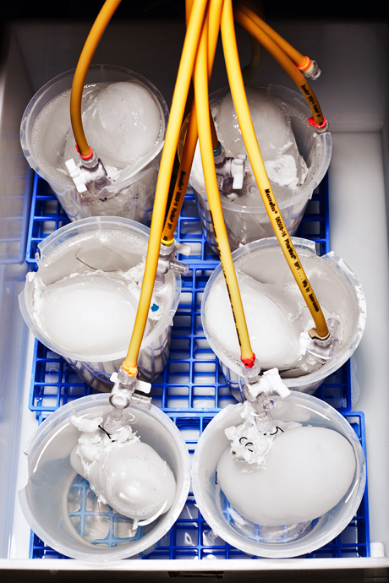
Mackenzie Stroh
Pig kidneys at Dr. Atala's lab, where they are being decellularized and reseeded with human kidney cells.
Published in the April 2013 issue

One day, when you are ill, when your heart finally beats a thousand times too many, when your liver is sclerotic beyond use, when your pancreas stops producing insulin, when your kidneys no longer protect you from toxins, Dr. Anthony Atala wants to heal you. In his vision, you will visit a hospital in Omaha or San Francisco or Buffalo, and a specialist will diagnose you. Then you'll have blood taken to determine your genetic makeup, and then those results will be transmitted to an office manager in charge of a sterile white room in North Carolina that Atala has built. In a few days a small vial of stem cells that match your immunological profile perfectly will be extracted from a cryogenic tank in that room and shipped to your surgeon, who will use them to build you a new organ from scratch. It will take four to eight weeks to build and grow and implant the organ, and then you will be whole once again.
This is not a new dream.
Ever since human embryonic stem cells were first harvested and maintained outside the body in 1998, scientists and surgeons and politicians and patients have conjured up different versions of this dream.
But in fifteen years, embryonic stem cells have yielded no major clinical advancements or treatments, let alone made-to-order organs.
You can blame scientists for overpromising or fervent ideologues for halting research or private companies for strangling research with patents or the FDA for building clinical barriers too high.
Or you can ask Anthony Atala what he plans to do about it.

Nearly every scientist who talks about Anthony Atala describes him the same way. Visionary. Created a field. Architect of tissue engineering. This morning, the visionary accelerates his gold Honda Pilot in fits, misses turns, then accelerates again. The car has a huge crack down the windshield, which he hasn't yet had a moment to fix, and there are Taco Bell crumbs in the backseat left over from his two sons.
He's up by 4:30 a.m. or earlier seven days a week, sending e-mails about grants and research. Then he mashes the pedal in morning darkness to the Wake Forest University Baptist Medical Center, where he is the chair of the urology department. He still operates one day a week, six pediatric patients in a row, their parents waiting anxiously in the waiting room as he cuts into their tiny torsos and repairs hernias and torsions and worse.
The three hundred biologists and physiologists and engineers and chemists he oversees at the Wake Forest Institute for Regenerative Medicine watch as he torpedoes through the hallways from meeting to phone call to meeting, his high-pitched cackling laugh the only indication of where he is or in which direction he's moving. He is fifty-four and has a slightly shaggy head of wavy black hair that makes his perpetual grin and full cheeks even more boyish. "We should start," Atala says. "I have a call. Not sure with who, but we should start. Let's go, let's go." He doesn't say this in a gruff way, but with a disarming laugh. As in, Can you believe how crazy this is?
And it is crazy. He's crazy. By their oath, doctors fix and they heal, but they have up to now not created. What Atala and his tissue regenerators do and seek to do is, quite simply, in another realm of science and understanding altogether, born of the genius decoded from our own cells.
"I use this term with the greatest respect — [he's] kind of a modern Dr. Frankenstein," says Edward Tenthoff, a biotech analyst at Piper Jaffray who's closely followed Atala's career. "He is truly a visionary in his view of where he's taking the science."
In 1997, when he was thirty-eight and working at Harvard, Atala created the world's first tissue-engineered organ. He built it by hand. He took a stamp-sized biopsy of healthy cells from a little boy's broken bladder. He put them into a petri dish and fed the cells with proteins and nutrients until they mistook the petri dish for the human body and began multiplying and dividing as if still in the womb. He painted the new cells onto a biodegradable collagen balloon. A few weeks later, he sewed that cell-coated balloon — which had grown to become a new bladder — into the boy. Today that boy and many others who received the same operation are healthy college kids.
A couple years later, working with scientists at Advanced Cell Technology, he created the world's first cloned organs, mini bovine kidneys that pulled toxins from the bloodstream of the cows in which they were implanted. In 2007, when he realized that what was truly holding tissue engineering back were better, more reliable cellular building materials that could be sewn into patients without the problem of immunological rejection, he discovered an entirely new class of stem cells in amniotic fluid. The discovery made the front pages of newspapers across the country.
That child in London who received an artificial windpipe last year that will grow with him? A protégé of Atala's helped build it. The urologist in Los Angeles who is injecting stem cells directly into kidneys to keep people off dialysis? He trained in Atala's lab.
Atala has built blood vessels.
These are tubular and involve two types of cells, those on the interior that control fluid and those on the exterior that contract. But he figured out a way to build both using a machine that sprays collagen over a spinning rod to form a tubular scaffold. Then the cells are dripped on with a pipette, by hand. The vessels contract, blood and oxygen are ferried through the body.
He's built skin.
Soon men and women with horrible burns will be laid upon a table. A laser will scan their wounds and transmit their location and depth to a nozzle that will spray new skin cells right onto their damaged bodies. The work is backed by the U. S. Army, which hopes to treat its more gravely burned soldiers this way.
He's built livers, which are constructed cellular layer by cellular layer with a 3-D printer, until they literally come to life. He's built sphincters and urethras and heart valves. They beat, beat, beat.
Atala wants nothing less than to eradicate all chronic disease. Heart disease, kidney disease, short-bowel syndrome, testicular cancer. Done. Fixed. Gone. In Atala's future, we will no longer be burdened by our broken body parts. We'll just replace them with new ones.
But after two decades slogging through the stem-cell war, Atala's learned that science is science, and then it gets released into the world and becomes something else entirely — a political cudgel, ideological ammunition. When he advocated for embryonic-stem-cell research, he became a villain to the Right. When his lab discovered a source of stem cells that wouldn't necessitate the destruction of embryos, he became a figure of suspicion on the Left. In 2007, his work — his name — was used to argue both for and against embryonic-stem-cell research on Capitol Hill. The same research! He knows that in 2013, every scientific discovery is fuel for or against a point of view. And so he will protect his project, what he calls "my life's work," at all costs.
And what is his life's work? It's a public stem-cell bank he is establishing so that any and every person has the material needed to build nearly any organ.
"I don't worry about politics. It's not my concern," he says. His voice is soft, but there is finality to its tone. No, he won't depend upon ideologues or politicians for permission to pursue his life's work. They're mere distractions.
Deep in his laboratory right now, twenty-four pig kidneys are suspended in whirling water mixed with soap and solvents. Over one day, the bright-red organs turn pink, then white, then nearly translucent as their cells and DNA are washed away. The remaining jellylike infrastructure is then reseeded with human cells from the inside out. Twenty-two different types of cells in all.
Because all of these organs are built using adult stem cells from the patients who would receive them, there's no risk of tissue rejection.
He's building all of these things. Some, like the bladders and urethras, are in patients today. Others, the kidneys and hearts, are still being perfected in animals.
But there are things he can't build, at least not yet.

